P. SRI NIDHI

VU21CSEN0300029

ADVANCE CODING - 1

**1. C Program to Calculate Sum of Digits of a Number**

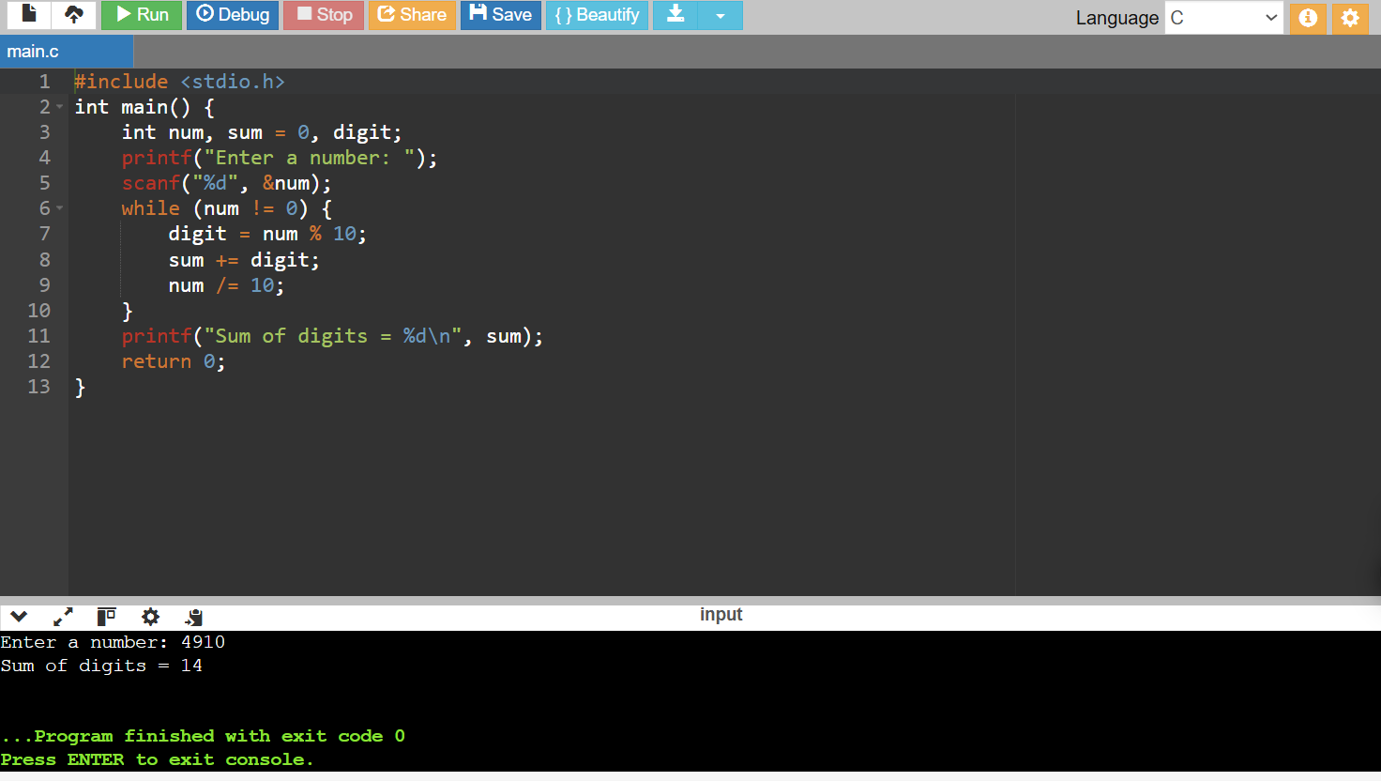

**2.** **Write a C program to find first and last digit of a number.**

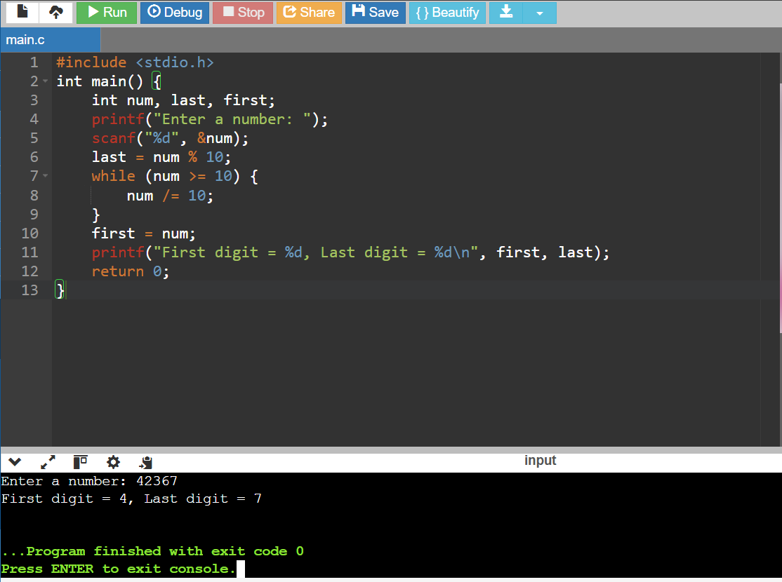

**3. Write a C program to find sum of first and last digit of a number.**

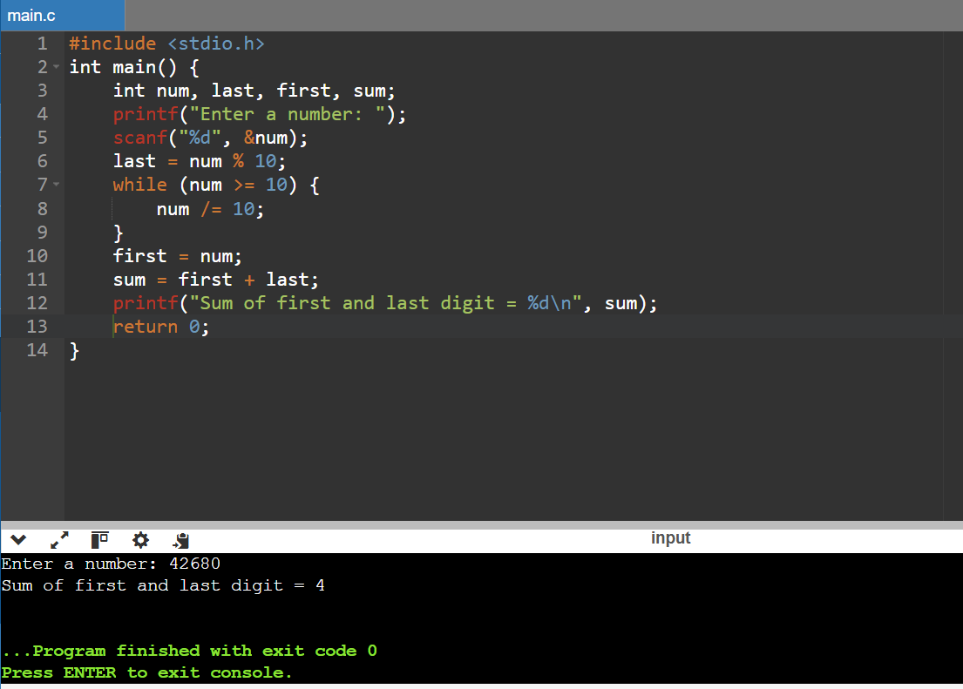

**4. Write a C program to swap first and last digits of a number.**

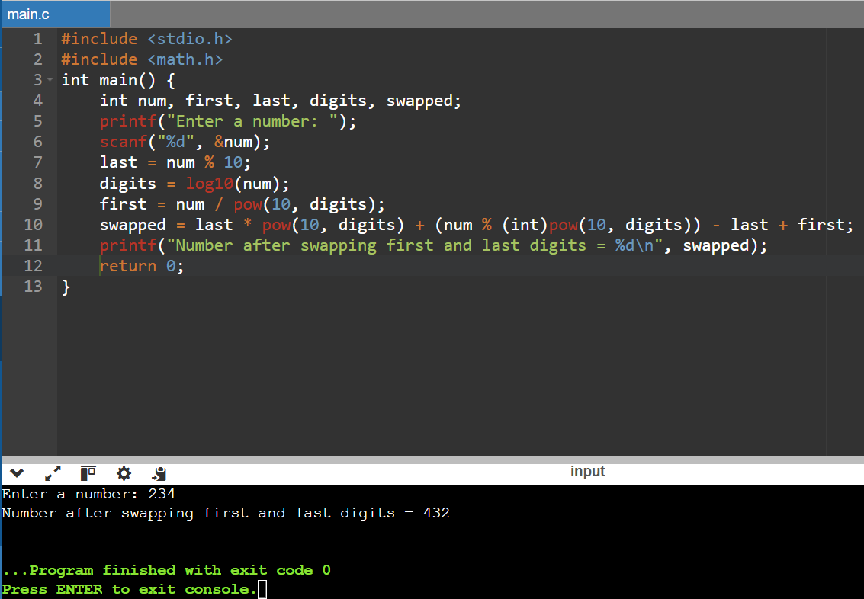

**5. Write a C program to find frequency of each digit in a given integer.**

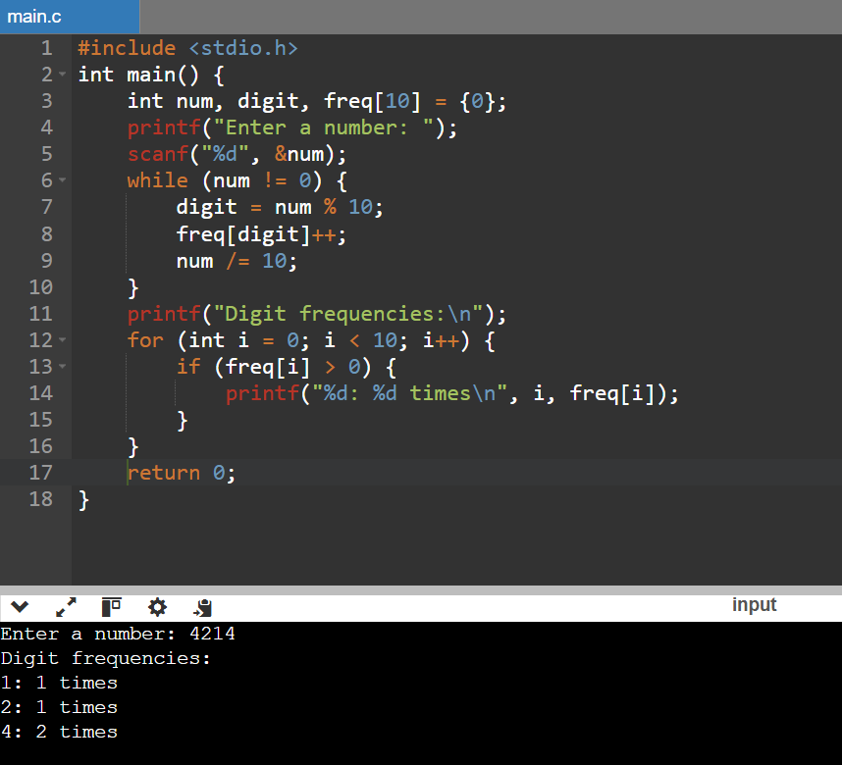

**6. Write a C program to enter a number and print it in words.**

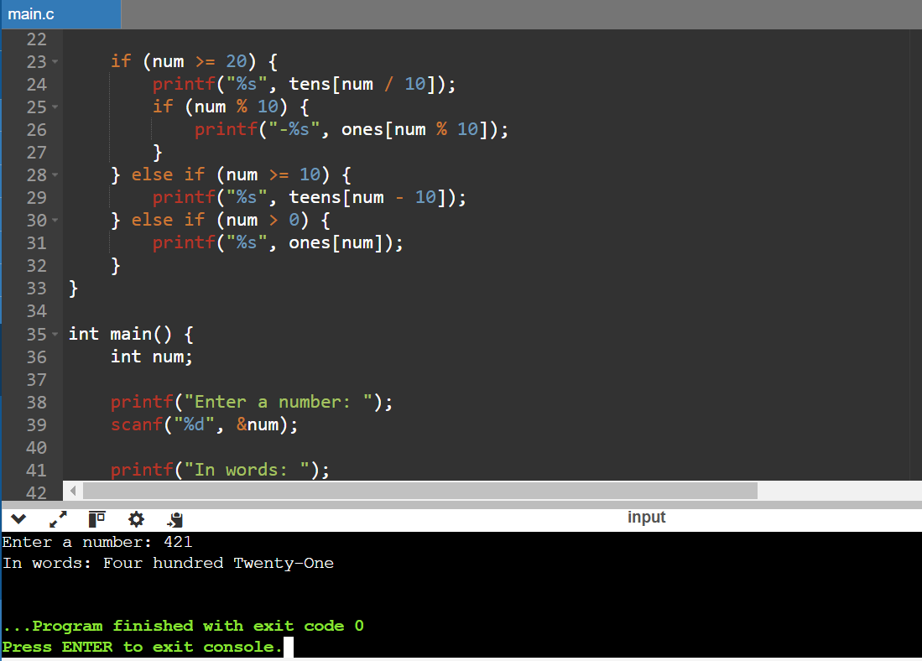

**7. Write a C program to find one’s complement of a binary number.**

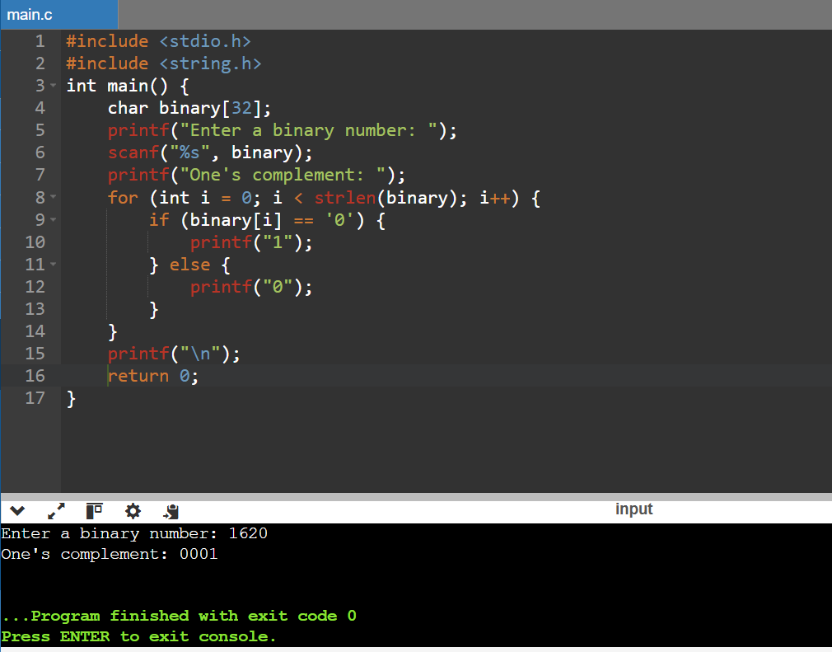

**8. Write a C program to find two’s complement of a binary number.**

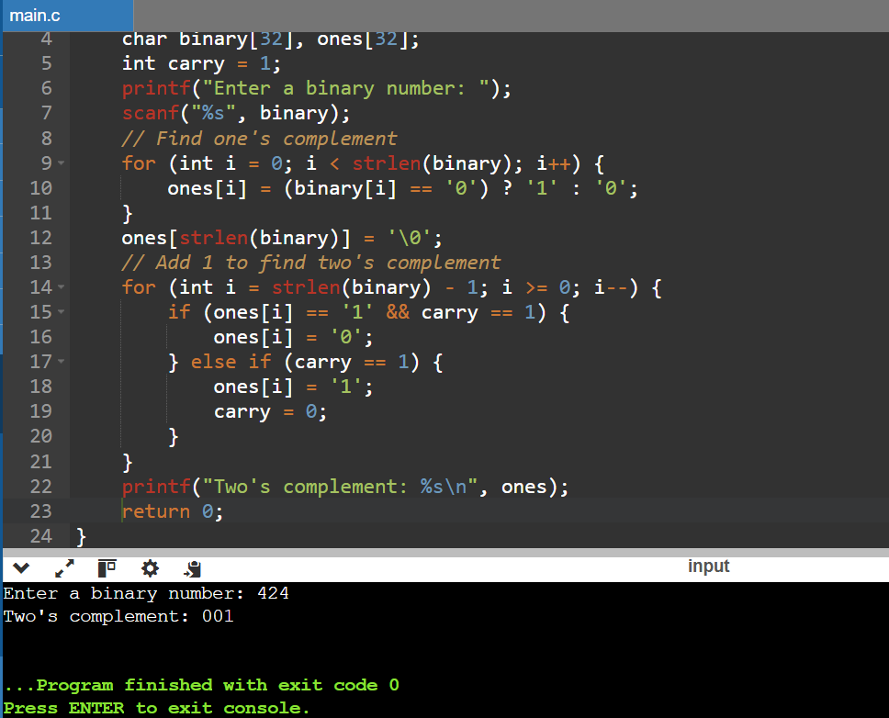

**9. Write a C program to convert Decimal to Hexadecimal number system**

